> class(Harman23.cor)

1. "list"

Harman23.cor数据集是list类型

> fa.parallel(Harman23.cor$cov,n.obs = 302,fa="pc",n.iter = 100,show.legend=TRUE,main ="scree plot with parellel analysis")

> abline(h=1,lwd=1,col="grey")#添加一条水平直线y=1，线宽为4

Parallel analysis suggests that the number of factors = NA and the number of components = 2

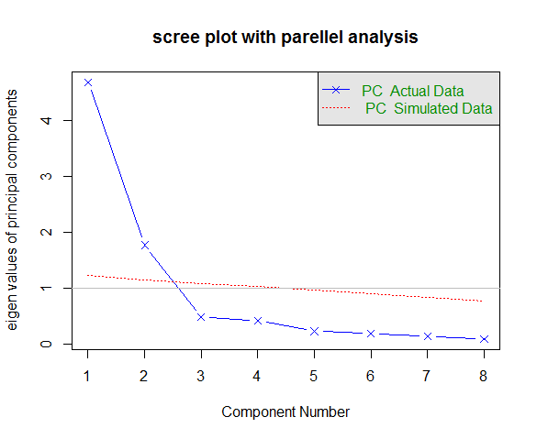

解释：

由上图可知特征值大于1和100次模拟的平行分析表明保留2个主成份最为合理

> pc<-principal(Harman23.cor$cov,nfactors = 2,rotate = "none")

> pc

Principal Components Analysis

Call: principal(r = Harman23.cor$cov, nfactors = 2, rotate = "none")

Standardized loadings (pattern matrix) based upon correlation matrix

PC1 PC2 h2 u2 com

height 0.86 -0.37 0.88 0.123 1.4

arm.span 0.84 -0.44 0.90 0.097 1.5

forearm 0.81 -0.46 0.87 0.128 1.6

lower.leg 0.84 -0.40 0.86 0.139 1.4

weight 0.76 0.52 0.85 0.150 1.8

bitro.diameter 0.67 0.53 0.74 0.261 1.9

chest.girth 0.62 0.58 0.72 0.283 2.0

chest.width 0.67 0.42 0.62 0.375 1.7

PC1 PC2

SS loadings 4.67 1.77

Proportion Var 0.58 0.22

Cumulative Var 0.58 0.81

Proportion Explained 0.73 0.27

Cumulative Proportion 0.73 1.00

Mean item complexity = 1.7

Test of the hypothesis that 2 components are sufficient.

The root mean square of the residuals (RMSR) is 0.05

Fit based upon off diagonal values = 0.99

解释：由Proportion Var结果可知PC1解释了58%的方差，PC2解释了22%的方差，两者累计解释了81%的方差

> pc<-principal(Harman23.cor$cov,nfactors = 2,rotate = "varimax")

> pc

Principal Components Analysis

Call: principal(r = Harman23.cor$cov, nfactors = 2, rotate = "varimax")

Standardized loadings (pattern matrix) based upon correlation matrix

RC1 RC2 h2 u2 com

height 0.90 0.25 0.88 0.123 1.2

arm.span 0.93 0.19 0.90 0.097 1.1

forearm 0.92 0.16 0.87 0.128 1.1

lower.leg 0.90 0.22 0.86 0.139 1.1

weight 0.26 0.88 0.85 0.150 1.2

bitro.diameter 0.19 0.84 0.74 0.261 1.1

chest.girth 0.11 0.84 0.72 0.283 1.0

chest.width 0.26 0.75 0.62 0.375 1.2

RC1 RC2

SS loadings 3.52 2.92

Proportion Var 0.44 0.37

Cumulative Var 0.44 0.81

Proportion Explained 0.55 0.45

Cumulative Proportion 0.55 1.00

Mean item complexity = 1.1

Test of the hypothesis that 2 components are sufficient.

The root mean square of the residuals (RMSR) is 0.05

Fit based upon off diagonal values = 0.99

解释：旋转的作用是对成分去噪。进行方差极大旋转，由Proportion Var结果可知RC1解释了44%的方差，RC2解释了37%的方差，两者累计解释了81%的方差,与未旋转前一样。旋转以后的ssloading最小值2.92比未旋转的最小值1.77大，所以做主成份分析可以用未旋转的结果。